Nwf: The [**Iberian lynx**](http://www.nwf.org/News-and-Magazines/National-Wildlife/Animals/Archives/2006/Can-Spain-Save-the-Worlds-Most-Endangered-Cat.aspx) has fewer than 150 adults in the wild.

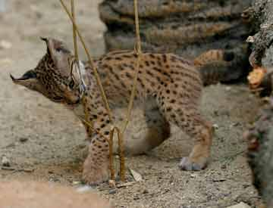

Darwin’s Fox’s Status: Critically Endangered; lives only on Chiloé Island off Chile, where fewer than 250 mature adults range today.

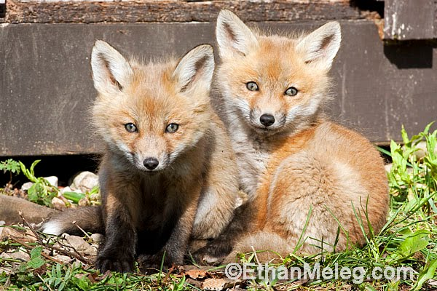

### Celebes Crested Macaque’s Status: Critically Endangered. These heavily poached animals have gone from over 300 per square mile to under 60.

### Yunnan Snub-Nosed Monkey

#### Status: Endangered

Living in forests at elevations exceeding 10,000 feet—higher than any other primate—this species was largely unknown to science until the 1990s. ”I vowed to document its life,” says photographer Xi Zhinong, who has been active in efforts to conserve the species. Today, fewer than 2,000 of the animals are thought to survive in the remote mountains of southwestern China, where Xi made this portrait of a family group (above, right) during spring in the region’s Baima Snow Mountain Nature Reserve.

### Saiga Antelope

#### Status: Critically Endangered

Equipped with a bulbous hump on its nose that filters out dust blowing across the dry steppes where it lives, this male saiga (below, left) is a potential target for poachers who seek its horns for a lucrative illicit medicinal trade in Asia. To photograph the species, Igor Shpilenok traveled across hundreds of miles of rugged terrain in a four-wheel-drive vehicle to reach one of its last domains: the Cherny Zemly Zapovednik nature reserve in southwestern Russia, where the number of male saigas has been decimated. By one estimate, 500 or more females may sometimes vie for a single male during breeding season.

